**1D CU & CURH Scheme results summarised**

**(Fortran and C++ Code results)**

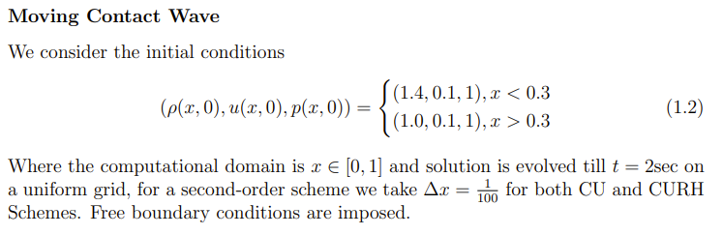

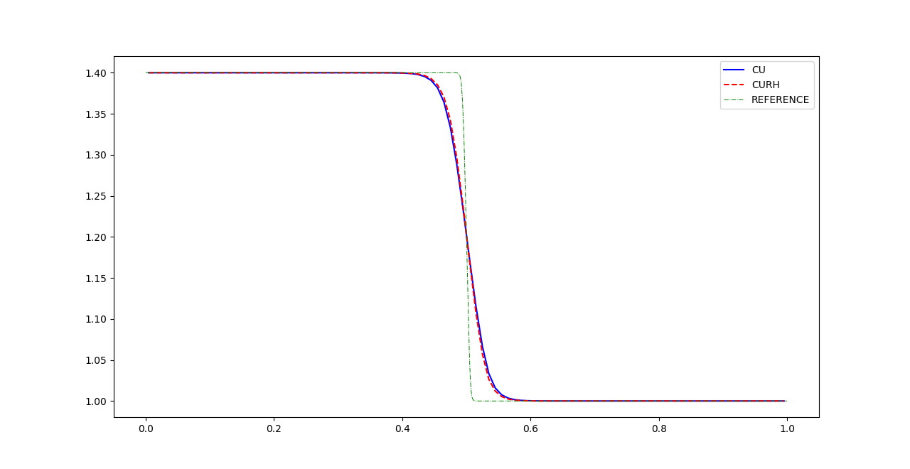

Figure Moving Contact Wave (Fortran)

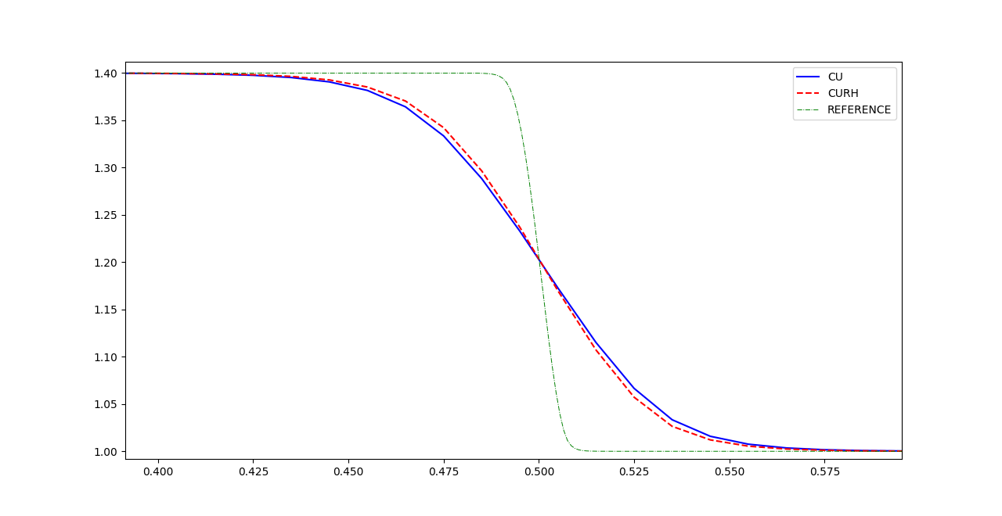

Figure Moving Contact Wave Zoomed (Fortran)

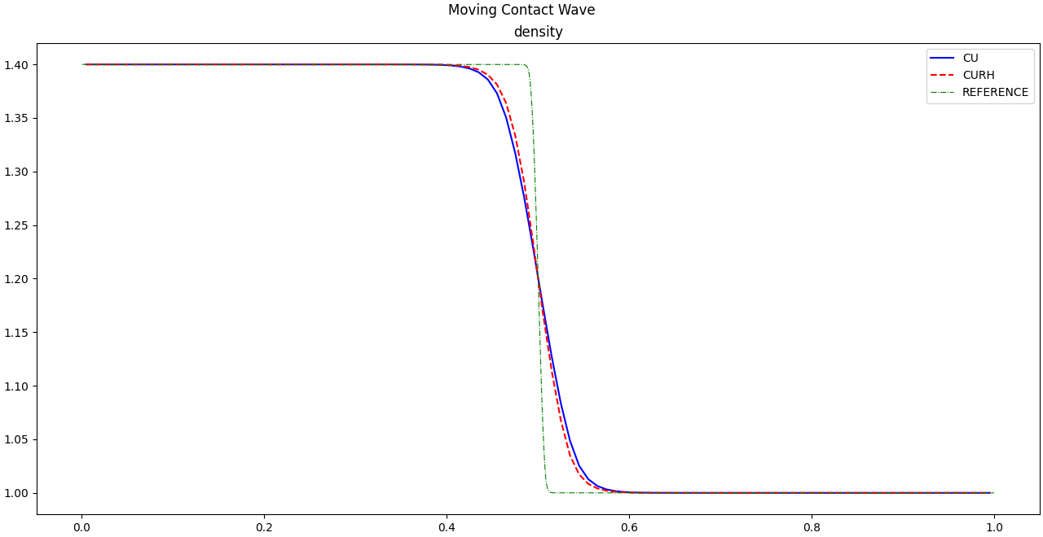

Figure Moving Contact Wave (C++)

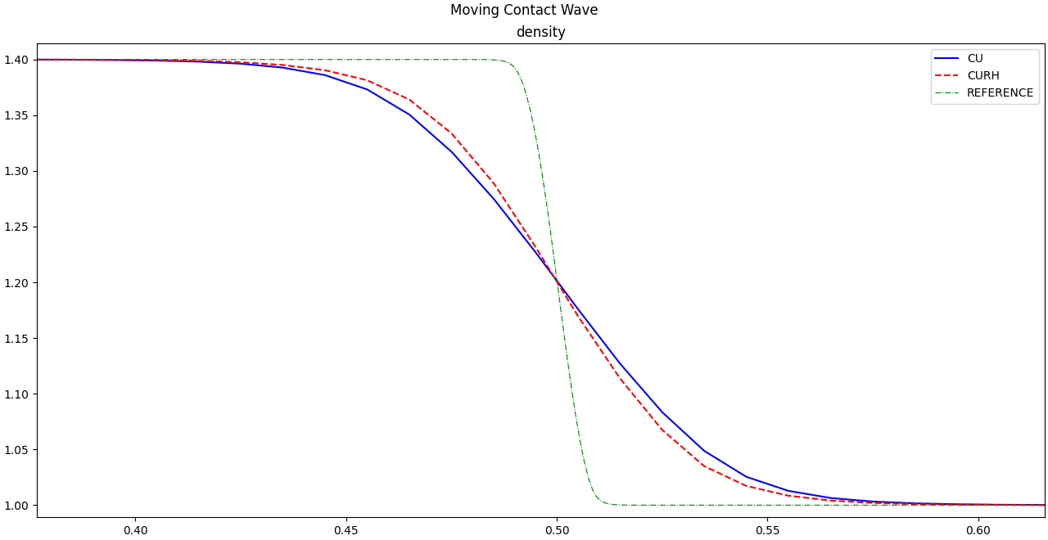

Figure Moving Contact Wave Zoomed (C++)

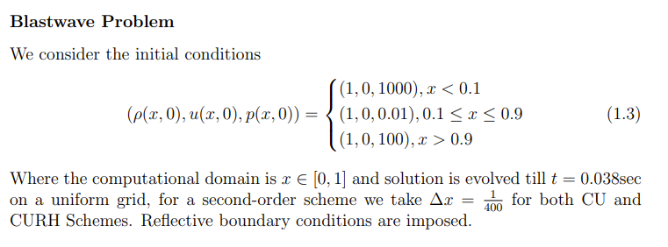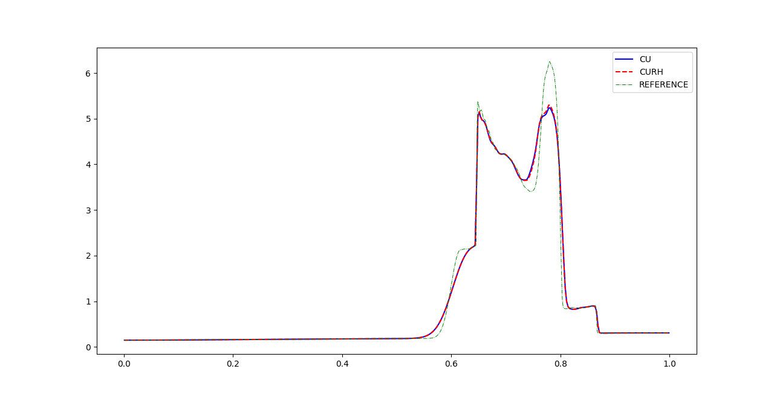

Figure Blastwave Problem (Fortran)

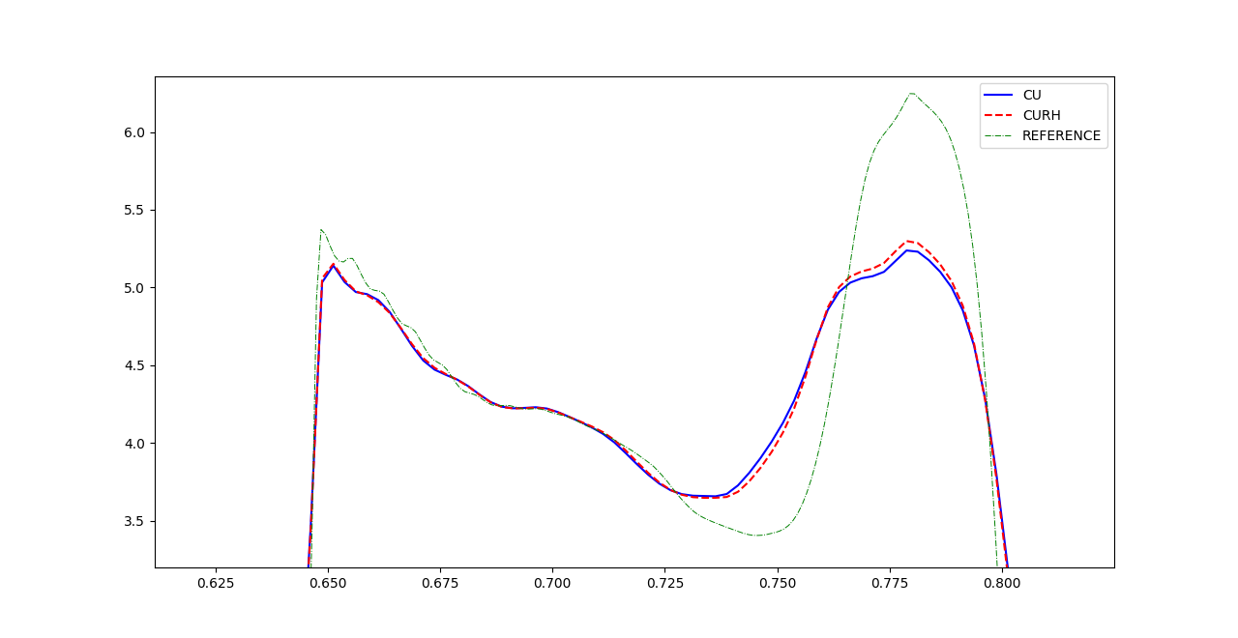

Figure Blastwave Problem Zoomed (Fortran)

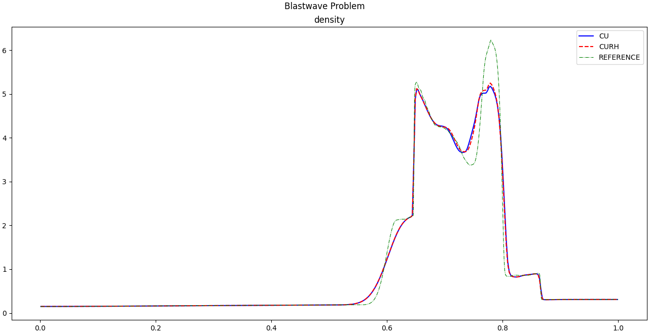

Figure Blastwave Problem (C++)

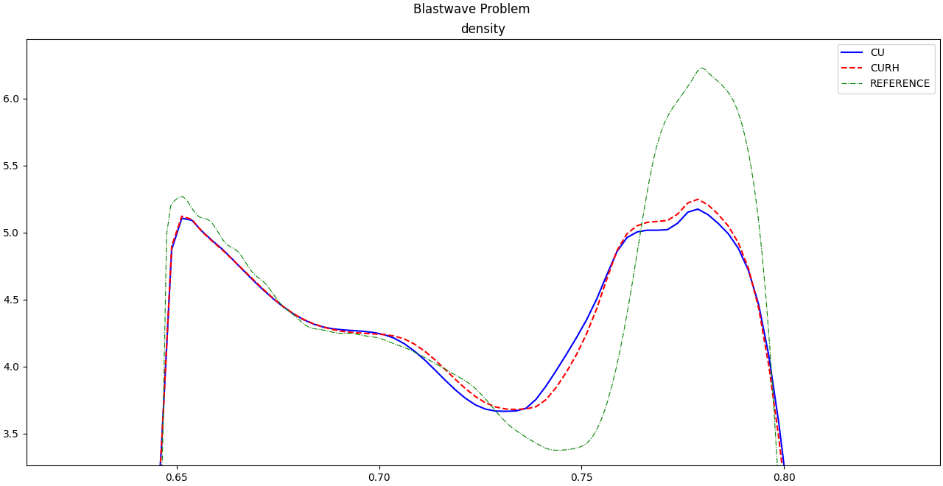

Figure Blastwave Problem Zoomed (C++)

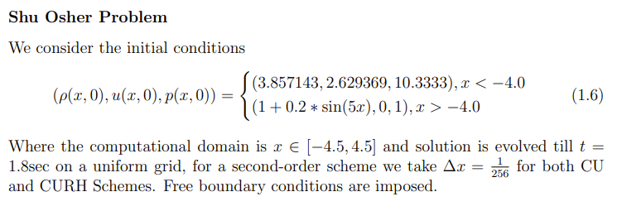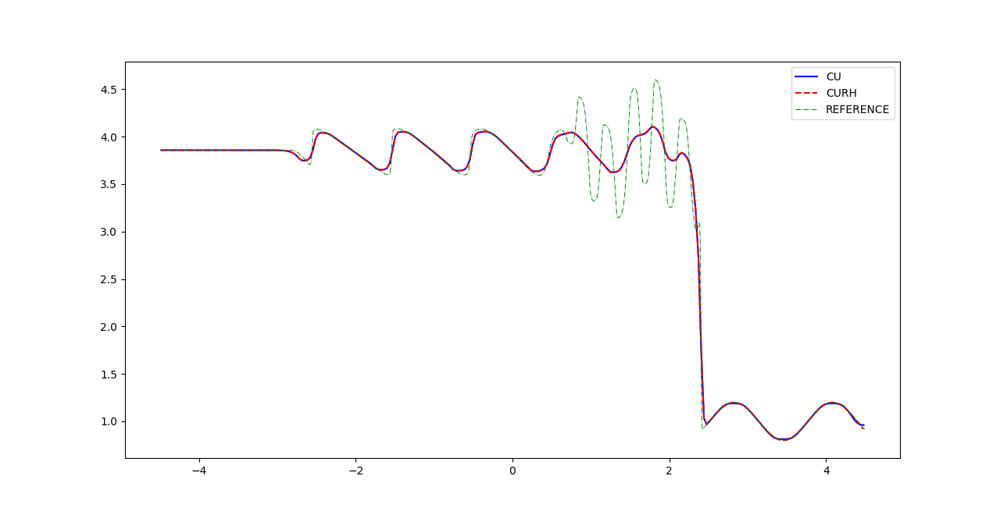

Figure Shu Osher Problem (Fortran)

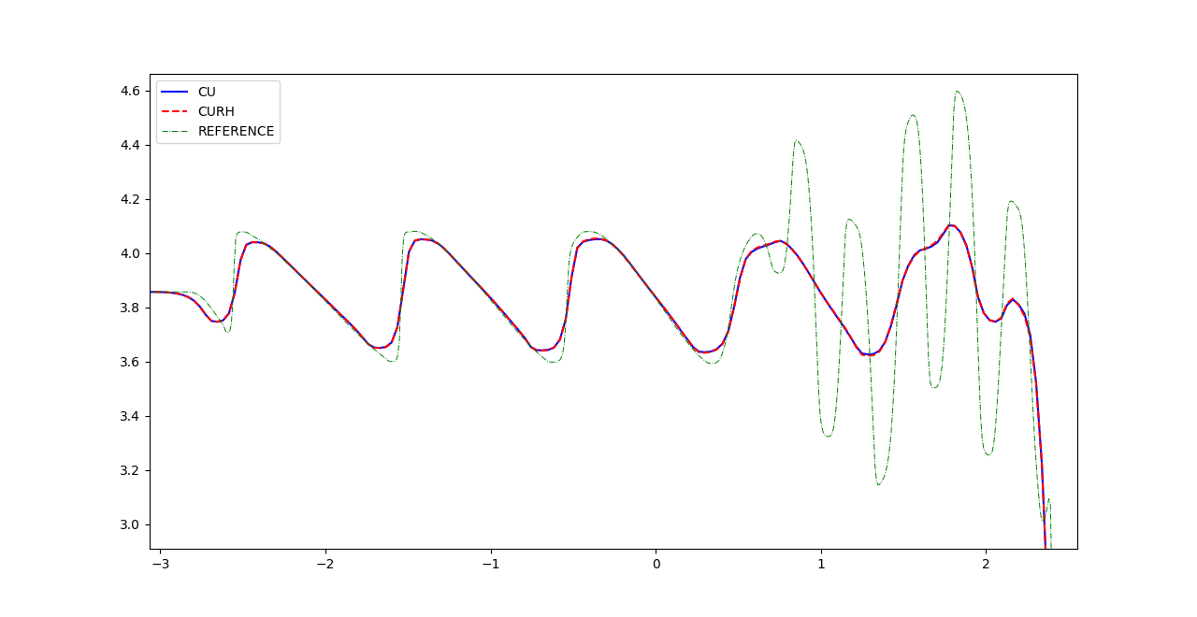

Figure Shu Osher Problem Zoomed (Fortran)

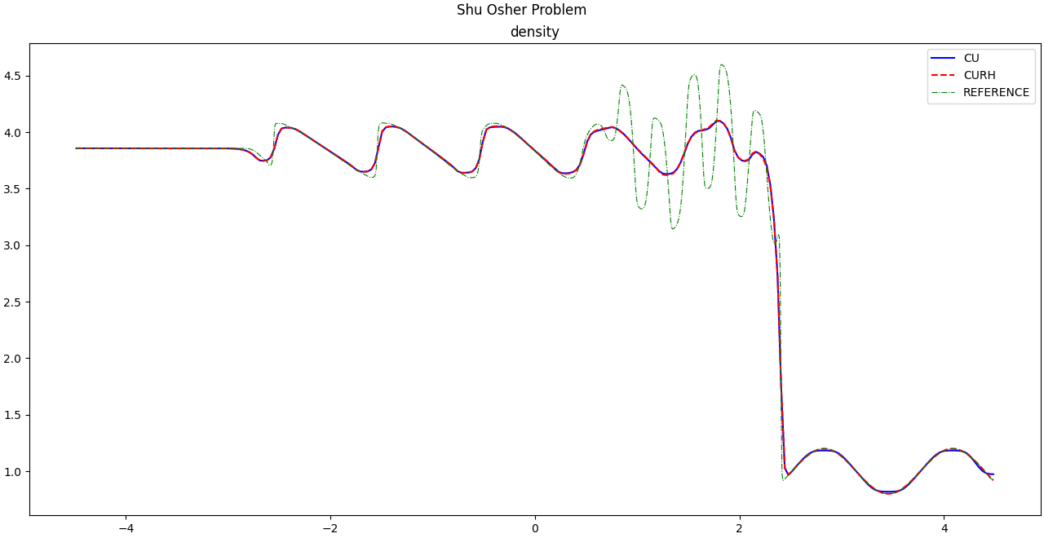

Figure Shu Osher Problem (C++)

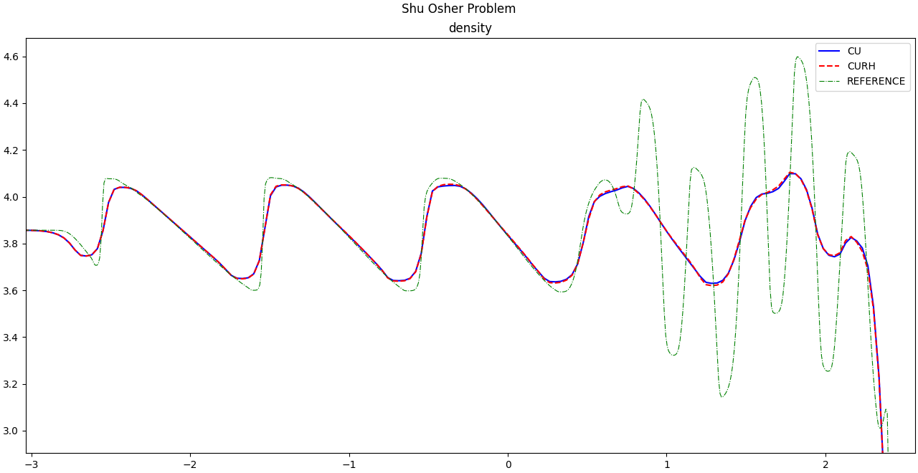

Figure Shu Osher Problem Zoomed (C++)

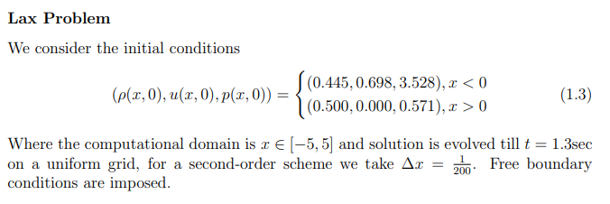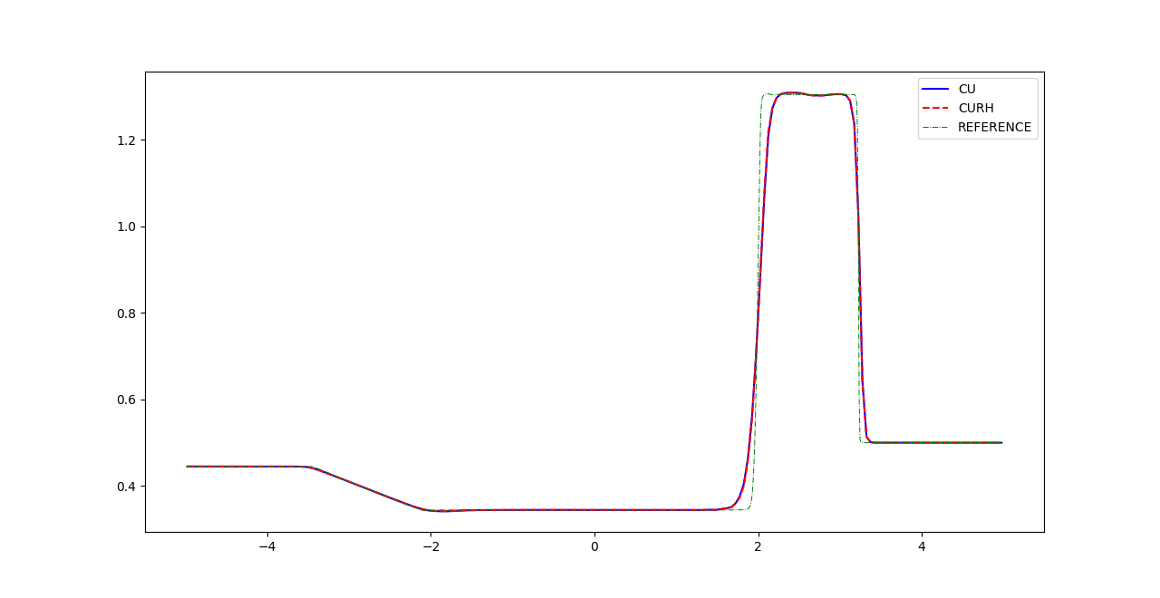

Figure Lax Problem (Fortran)

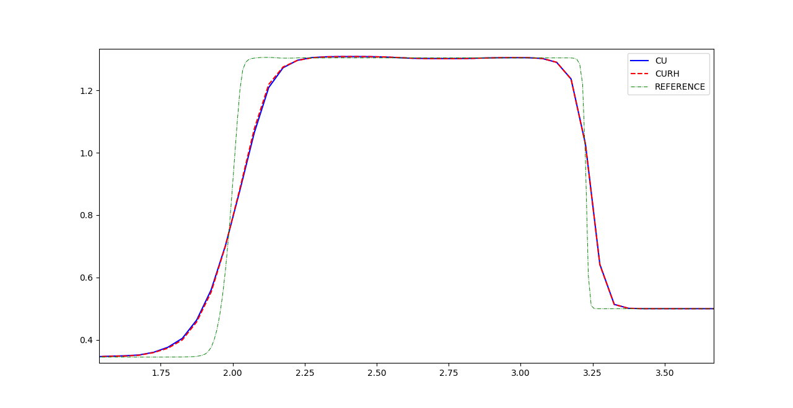

Figure Lax Problem Zoomed (Fortran)

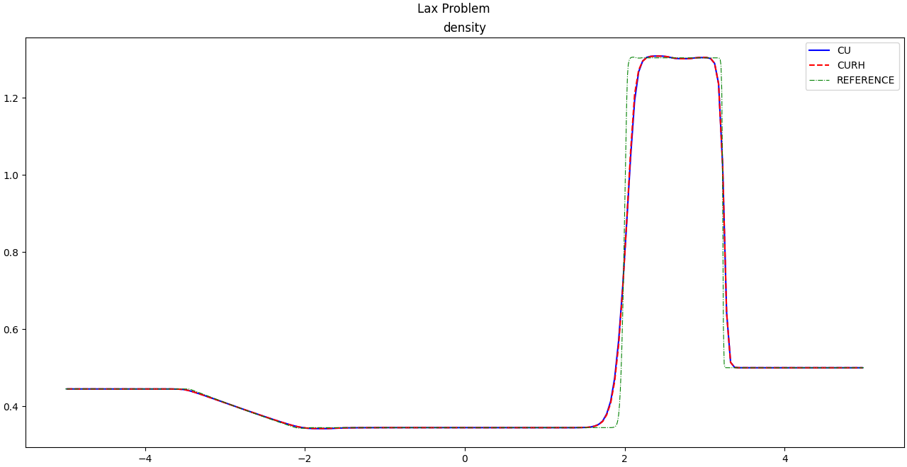

Figure Lax Problem (C++)

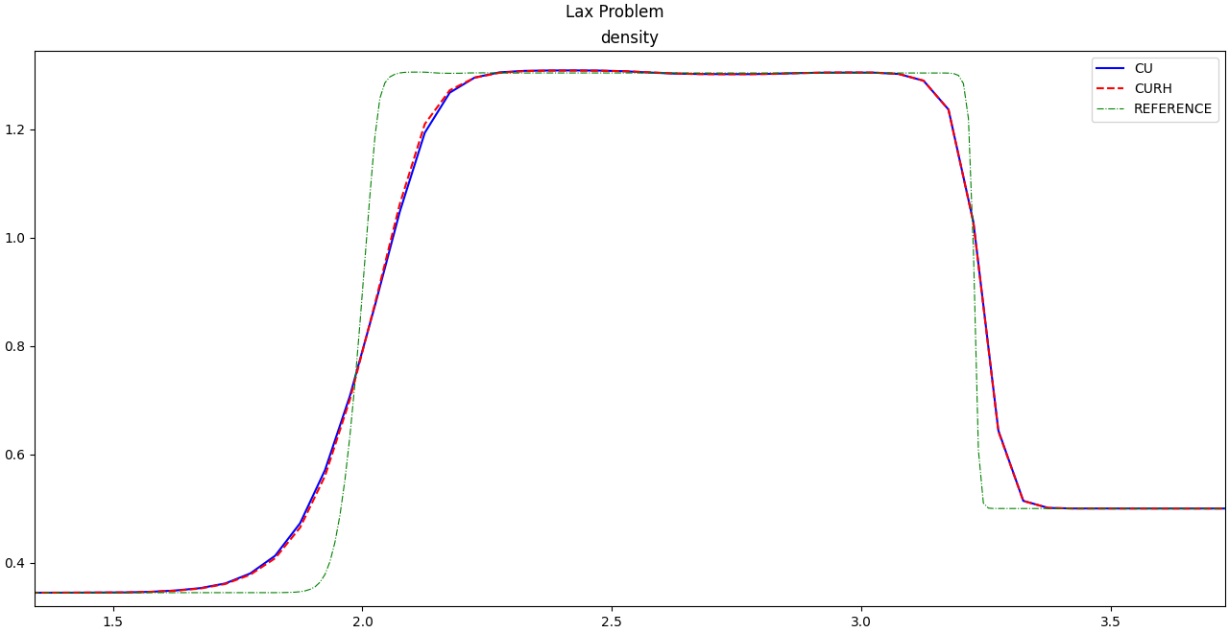

Figure Lax Problem Zoomed (C++)

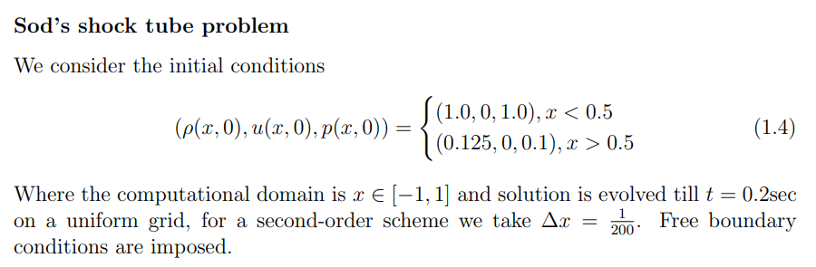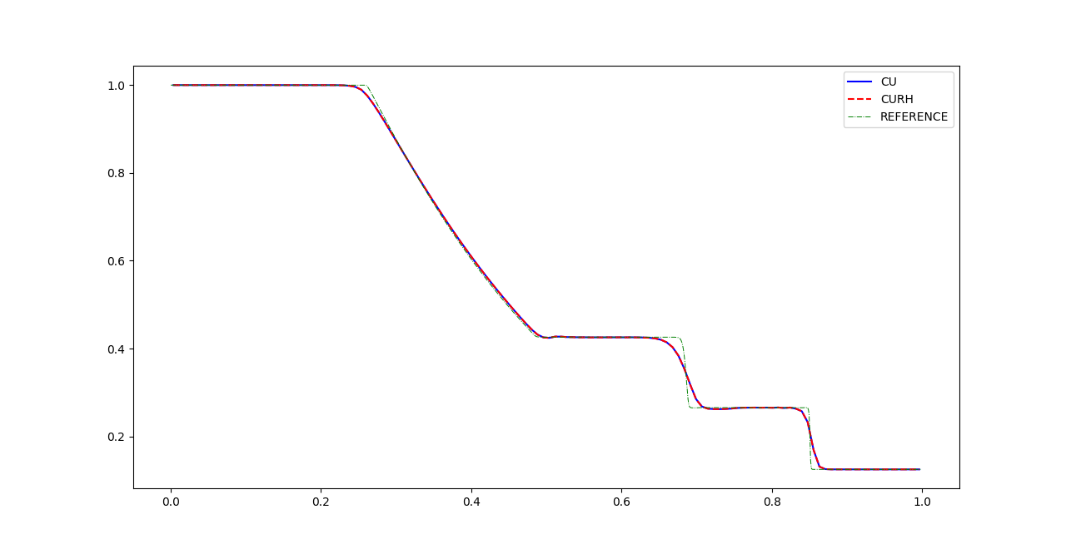

Figure Sod's Shock Tube Problem (Fortran)

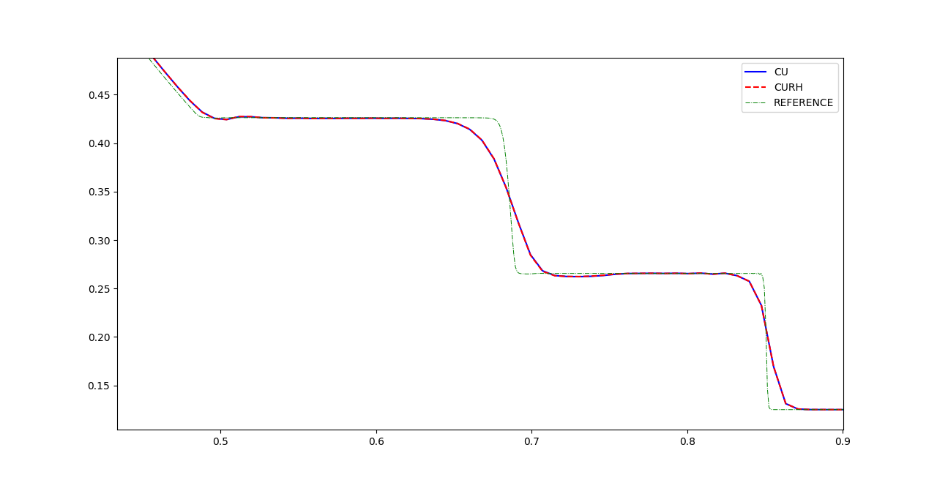

Figure Sod's Shock Tube Problem Zoomed (Fortran)

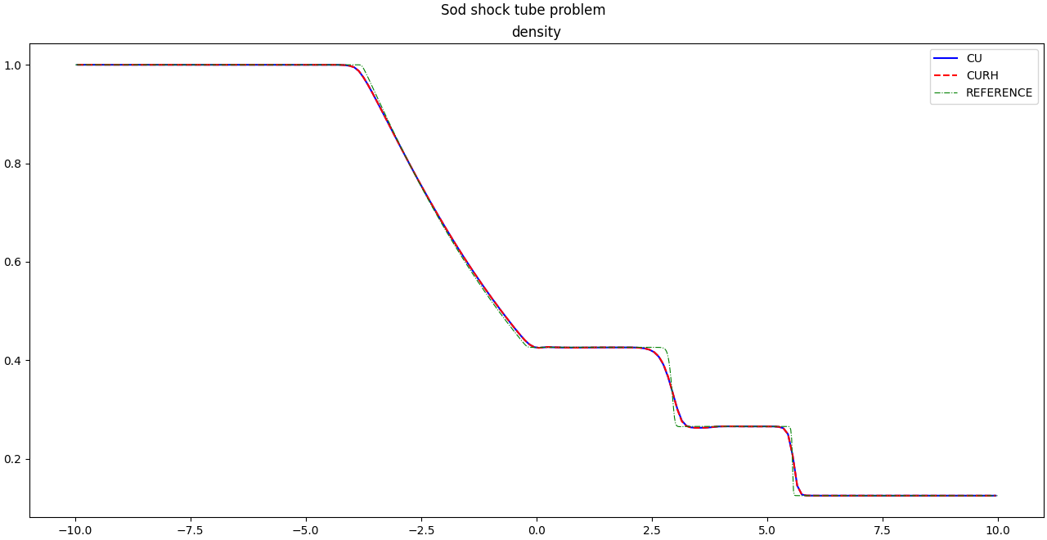

Figure Sod's Shock Tube (C++)

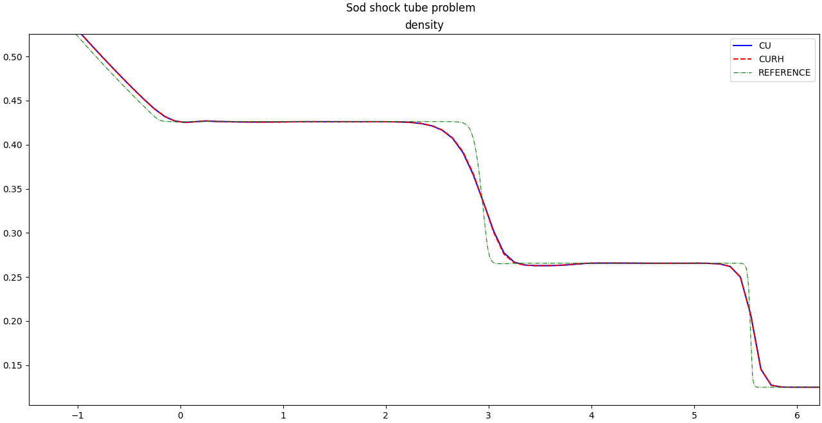

Figure Sod's Shock Tube Zoomed (C++)